Use of Biometric Data Consent

As you are aware, we operate a cashless catering system for canteen purchases via an automated biometric machine that recognises your child’s thumbprint data. The biometric system is hosted for us by CRB Cunninghams. In order to comply with current legislation (GDPR and the Data Protection Act 2018), we will need to scan your child’s thumb and must ask you to provide consent by completing the attached form.

The biometric (fingerprint) identification system is endorsed by the DfE. It uses the thumb to uniquely identify each student by measuring many aspects of the thumb, which in turn gets translated into a unique identification code. This data is encrypted and held on a secure computer with no external access. The system does not store an image of the thumbprint.

The cashless catering system negates the need for students to carry cash. Students eligible for free school meals are also no longer distinguishable from other students, therefore removing any potential awkwardness associated with their entitlement. You will also be able to view what your child has purchased from the canteen, which will allow you to monitor what they are actually eating. Payment is made directly into their child’s account using ParentPay or your child will be able to deposit cash via the machines in school. Details regarding ParentPay will have been sent to you previously by the school but please contact us if you require a reminder.

We should be grateful if you would complete the attached consent form and return it to school indicating your choice. If you choose not to consent to your child’s thumbprint being used but still want them to use the canteen, they will be issued with a personal identification number (PIN).

You can withdraw your consent for the use of their thumbprint at any time by writing to the school. In addition, your child may at any time object or refuse to allow their biometric information to be used even if you have given your consent. We would appreciate it if you could explain this to your child.

Please would you complete the attached form to ensure your child will be able to use the canteen. If we do not have your reply, your child will not be able to use the canteen. Thank you for your assistance.

Yours sincerely
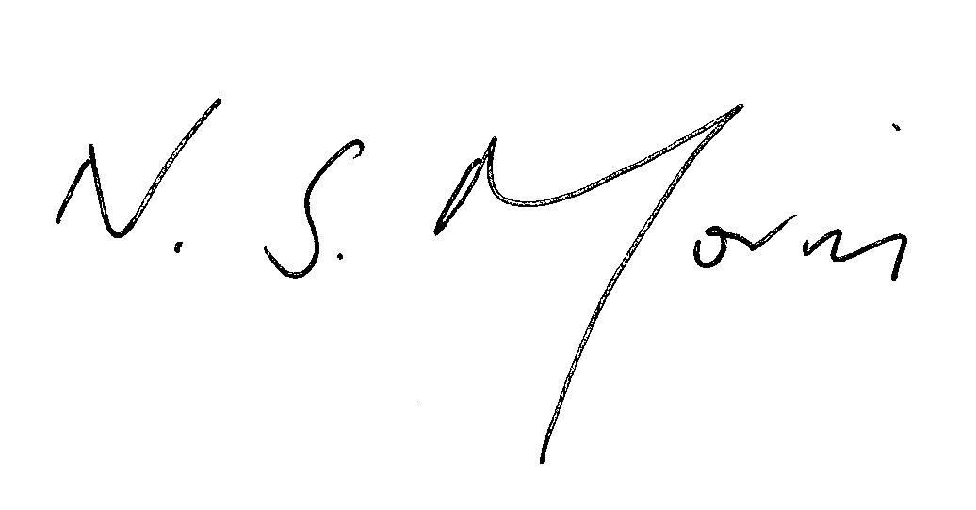

Neil S Morris
Headteacher

Please return to RECEPTION – Christopher Whitehead Language College

Use of Biometric Data – Consent Form

Please sign and date this form to indicate whether you consent to your child’s biometric information (as described in the letter attached) being used by the school as part of the biometric recognition system. This consent will remain until your child leaves the school or you subsequently withdraw your consent in writing. Upon leaving the school the student’s biometric information is automatically removed the system.

Student Name: ______________________________________ Learning Mentor Group: ___________

I consent to my child’s biometric information being used by the school in the ways described
in the Use of Biometric Data letter.

I do not consent to my child’s biometric information being used by the school and wish them
to be issued with a PIN code instead.

Signed: _______________________________ Print Name: __________________________________

Date: ____________________

